Art guidance
Use the template uploaded (it looks like the image below. Fill your person with pictures of all the things you enjoy doing that help your well-being. For example, spending time with friends, baking, reading, drawing etc.
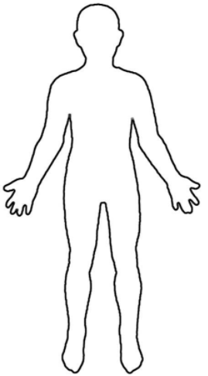
Then around the outside of your person, write down your qualities that make you, YOU! For example, kindness, patience, hard-working, resilient, helpful etc. Make it colour and fill the whole page! I would like to see these in our afternoon sessions!

