A Message from Sir David Attenborough Comprehension
https://www.youtube.com/watch?v=oQnDVqGIv4s

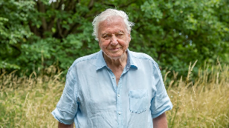
- Why is Sir David Attenborough speaking to you from his home?
- How do you think Sir David Attenborough feels about the challenges of the last year?
- Find and copy a word which shows that the last few months have been very difficult for many people.
- Sir David Attenborough says, “When we work together, there is no limit to what we can accomplish.” Which definition most closely fits the word ‘accomplish’?
- Cope with something very difficult.
- Look after babies and those in need.
- Achieve or successfully complete something.
- Eat a large amount of something.
- Find and copy a phrase which shows that we must do something about environmental change as soon as possible.
- In which city will the 2021 UN Climate Change Conference be held?
- Find and copy a phrase which shows that Sir David Attenborough believes the climate change conference is a very important event.
- List three groups that Sir David Attenborough hopes 2021 could be a year of positive change for.
- What does Sir David Attenborough hope you consider when making a New Year’s resolution?
- What does Sir David Attenborough mean when he says, “So here’s to a brighter year ahead.”?
- Why do you think the last 15 seconds of the video clip show images from the natural world without anything else being said by Sir David Attenborough?
- Complete the following table to show whether each statement is true or false.
 | True | False
Sir David Attenborough has spent the last two years in lockdown, alone in his home.
The United Nations Climate Change Conference is taking place in London this year.
Sir David Attenborough wants 2021 to be a happy new year for all the inhabitants of planet Earth.
A Perfect Planet is a new TV show made for Netflix.

- Could you summarise the key message conveyed by Sir David Attenborough in this clip in a single sentence.

