The Marine Iguana – KS2 Comprehension
https://www.youtube.com/watch?v=UDAutlF_aRY

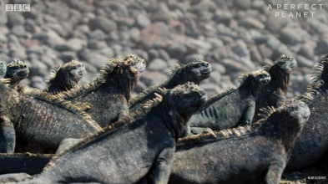
- Why is it surprising that the marine iguanas live on this island?
- Why do the cormorants bring seaweed ashore?
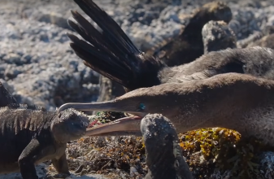
- Pause at 48 seconds. Pick a word to explain how you think first the cormorant and then the marine iguana feel at this moment.
Explain your two choices.
- Sir David Attenborough says, “Both of these species have evolved here.” Explain what the word ‘evolved’ means.
- Find and copy a phrase which tells you that the cormorant and marine iguana don’t always get along.
- What is unusual about where the marine iguana gets its food?
- Find and copy a phrase which shows that the marine iguana is dependent on the seaweed for survival.
- Sir David Attenborough says, “The seaweed, on which he totally relies, only grows in abundance here…” Can you think of a synonym and antonym for the word ‘abundance’?
- What is the name of the ocean current which brings the nutrients that enable the seaweed to grow?
- How long can the marine iguana spend underwater?
- Can you explain what would happen to the marine iguana if it was to spend too long in the water?
- Sir David Attenborough says, “Any longer than that and his muscles will seize up.” Can you explain what the phrase ‘seize up’ means?
- Which class of animal is unable to handle cold temperatures well?
- Complete the table to show whether each statement is true or false.
 | True | False
The main animal featured in this clip is a type of snake.
Cormorants bring seaweed onto the island.
Thousands of marine iguana live on the island.
The marine iguanas are carnivores.
- Order the following events from 1 – 5. One has been done for you.
- A marine iguana attempts to steal some seaweed. _
- A marine iguana stands on a cliff edge. 3
- A marine iguana searches for food in the sea. _
- A marine iguana is shown diving into the sea. _
- A cormorant brings seaweed ashore to build a nest. _
- Did you enjoy this clip? Explain your answer fully referencing what you have seen in the clip.
- Summarise the events of this clip in a single sentence.
EXT: Have a go at following this tutorial to draw an iguana of your own!
https://youtu.be/8KTg63pl0s4

