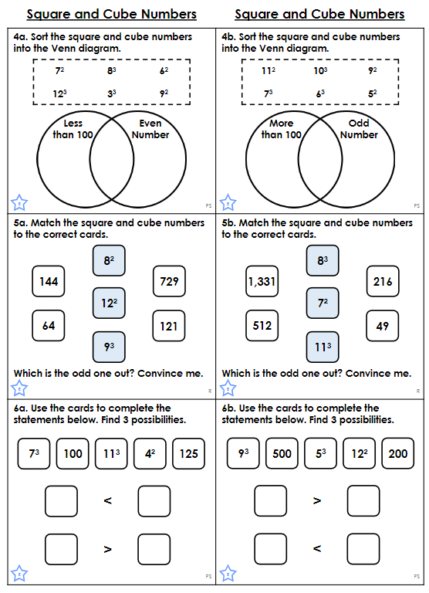

Choose which worksheet to complete (either E or GD) on problem solving with Square and Cube numbers. If you find E a bit more straight forward, then challenge yourself! Good luck!

