Animals Including Humans – camouflage
Watch this video: https://stemlearning.wistia.com/medias/3hylv5hccl
Complete the activity below- Write your findings on a Google Doc and send it to me! Take a photo of your moth on your camouflaged background if you can!
Activity: SPOT THE MOTH
- Choose a surface such as a wall, a tree trunk, a fence or any other vertical surface.
- Using the template below, design a moth which will be camouflaged against this surface. Use paints, crayons or felt tips to create suitable colouring and patterns OR use things in the environment to decorate it.
- Attach the completed moth to the surface.
- Stand as far away from the surface as possible, and then walk closer and closer until you spot the moth. Measure the distance to the moth when you spot it.
- Repeat with other moths.
- The moth with the shortest distance is most likely to survive, as a predator has to be really close up before it is spotted. Look carefully at the camouflage. Why was it successful and how does it compare to real moths?

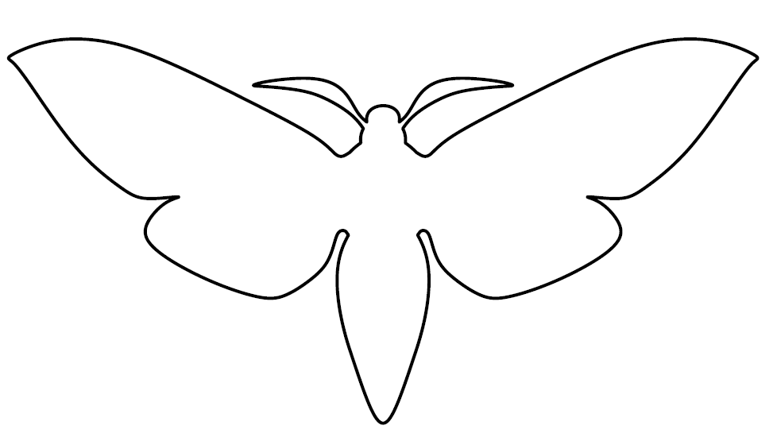
(moth-pattern, PatternUniverse.com, https://patternuniverse.com/download/moth-pattern/, Patterns may be used for personal, non-commercial purposes only. They may not be distributed or published elsewhere. You may download and print these for classes.)

Links to further activities:
https://www.stem.org.uk/elibrary/resource/29024
Look for the following downloads:
- Help the animals camouflage themselves - use pictures of animals and habitats to find out who goes where, where they will feel safe and maybe have a game of hide and seek with a helper.
- Camouflage Yourself – can you dress or decorate yourself so you blend into a background at home?
- Camouflage Notebook - get outside and see how many animals you can find. Use this booklet to record your own observations of how animals camouflage themselves.

