Wednesday 24th February 2021
OLI: To write a diary entry
Success Criteria:
- I can write in the first person
- I can use the past tense
- I can write in chronological order
- I can use time connectives

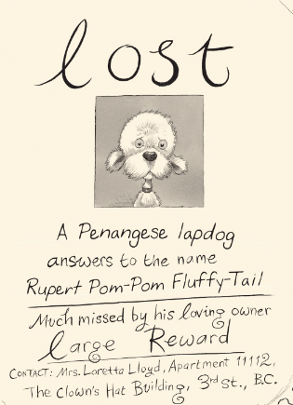

Imagine you are Mrs. Loretta Lloyd who has lost her dog.

Write a diary entry of the day you lost it. Remember that you will write the diary at the end of the day after you have already lost it and you are writing in the past tense.

Think about where you lost him and how you lost him. What did you do to try and find him?

