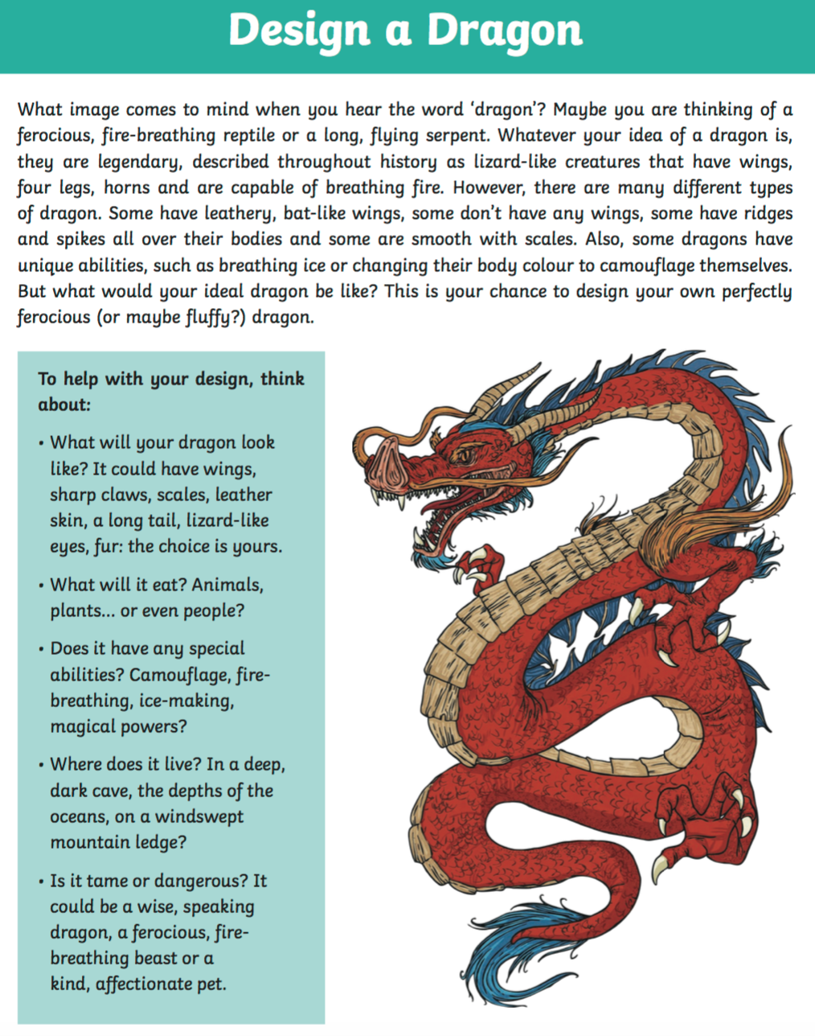

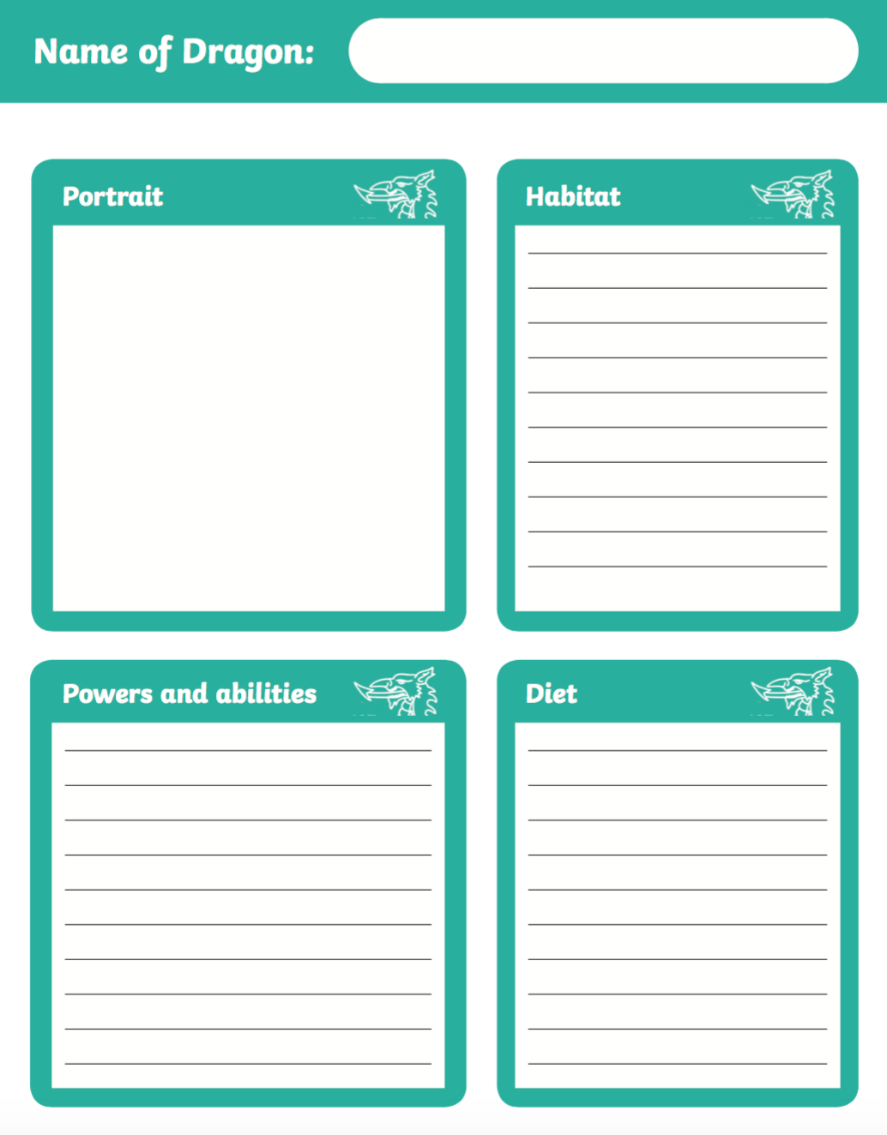

**Diet (what it eats) and where it lives**

**Powers (what can it do?)**

**Picture**

**What it looks like**

__________________________________________________________________________________________________________________________________________________________________________________________________________________________________________________________________________________________________________________________________________________________________________________

____________________________________________________________________________________________________________________________________________________________________________________________________________________________________________________________________________________________________________

____________________________________________________________________________________________________________________________________________________________________________________________________________________________________________________________________________________________________________