Is Humanity the Next Supervolcano? – KS2 Comprehension
https://www.youtube.com/watch?v=rbHk1ehQJSY
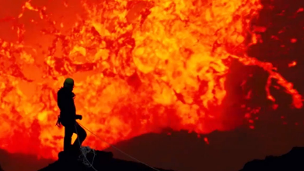
- How many mass extinction events do scientists believe the Earth has experienced in its history?
- Explain as clearly as you can what you understand the phrase ‘mass extinction event’ to mean.
- What has caused the majority of extinction events on Earth?
- Sir David Attenborough says, “Most were caused by cataclysmic volcanic eruptions.’ Which of these do you think is the most accurate definition of the word ‘cataclysmic’? Tick one.
- A small volcanic eruption.
- The global temperature increasing.
- A large-scale, violent event.
- A volcanic eruption caused by cats.
- Which invisible gas is released by volcanoes?
- What does the use of the word ‘most’ in the phrase “most were caused by…” tell you?
- Do you know of any other mass extinction events that were not caused by a volcanic eruption?
- The greatest volcanic eruption of all time is believed to have led to what rise in global temperatures?
- Find and copy a phrase that shows you that scientists are not certain about the consequences to temperature of the greatest volcanic eruption in Earth’s history.
- What percentage of life on Earth became extinct following the greatest mass extinction event?
- Who does Sir David Attenborough claim “is now acting like a super-volcano”?
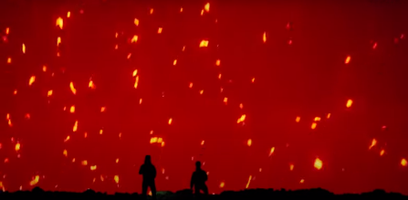
- Pause at 1.03. Explain fully how you think the people here might be feeling.
- Find and copy a phrase which tells you that humans are releasing more co2 than any previous super-volcano eruption.
- Sir David Attenborough says, “…that extinguished life in the past.” What does the word ‘extinguished mean’ in this phrase?
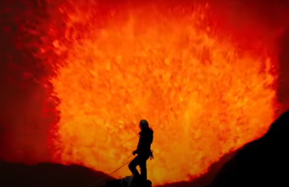
- Pause at 1.13. Why do you think the decision was made to end the clip with this image?
- This clip is designed to shock and scare. Collect three pieces of evidence which support this claim.
- Do you think it is fair of Sir David Attenborough to compare humanity to a super-volcano? Explain your answer fully using evidence from the clip and your own knowledge.

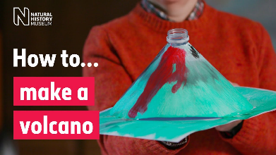
EXT: Have a go at making your own erupting volcano using this guide from the Natural History Museum - https://www.nhm.ac.uk/discover/how-to-make-a-volcano.html

